**Milestone 2**

**Devops Project**

**Name : Ankit Tiwari**

**Ps No. : 10844395**

**Problem Statement :**

**Create an end to end CI/CD pipeline in AWS platform using Jenkins as the orchestration tool, Github as the SCM, Maven as the Build tool, Deploy in a docker instance and create a Docker image, Store the docker image in ECR, Achieve Kubernetes deployment using the ECR image. Build a sample java web app using maven.**

**Project Starts ---------------------------------------------------------------------------**

**Approach: Declarative pipeline**

**Requirements:**

**✓ CI/CD declarative pipeline System**

**✓ Git - local version control system.**

**✓ GitHub - As Distributed version control system.**

**✓ Jenkins - Continuous Integration tool.**

**✓ Maven - As a Build Tool.**

**✓ docker -Containerization**

**✓ Kubernetes - As Container Management Tool**

**Steps :**

**Step 1: Source Code Setup**

* **Create an EC2 instance for hosting source code.**
* **Generate SSH key and add it to GitHub for the communication between my instance and the GitHub repository.**
* **Clone the repository containing the Java Project.**

**Step 2: Jenkins CI Setup**

* **Create a second EC2 instance for Jenkins.**
* **Connect via SSH and install:**
  + **Jenkins**
  + **Maven**
  + **Git**
* **Configure Jenkins:**
  + **Set JDK and Maven paths**
  + **Connect GitHub repository by generating the token and attaching it to the GitHub repository’s webhook.**
* **Create a new Jenkins item (Pipeline project).**
* **Write a Declarative Jenkinsfile to automate:**
  + **Build process**
  + **Docker image creation**
  + **Deployment steps**

**Step 3: Tomcat Deployment Setup**

* **Create a third EC2 instance for Tomcat deployment.**
* **Connect via SSH and install Tomcat.**
* **Start Tomcat and edit configuration files.**
* **Create Jenkins credentials for Tomcat deployer.**

**Step 4: Docker & AWS ECR Integration**

* **Create a fourth EC2 instance for Docker operations.**
* **Install Docker and configure AWS CLI using aws configure.**
* **Enable root login via SSH (sshd_config).**
* **Create a private ECR repository using AWS CLI.**
* **Add Jenkins pipeline steps to:**
  + **Build Docker image**
  + **Tag and push image to ECR**
* **Verify successful image upload to ECR after Jenkins build.**

**Step 5: Kubernetes Deployment on EKS**

* **Create a fifth EC2 instance for EKS deployment.**
* **Install:**
  + **AWS CLI**
  + **kubectl**
  + **eksctl**
* **Configure AWS credentials.**
* **Create an EKS cluster and node group.**
* **Create deployment.yaml and service.yaml files.**
* **Add Jenkins pipeline steps to:**
  + **Update kubeconfig**
  + **Apply Kubernetes manifests**
  + **Monitor rollout status**
* **Verify pod creation and load balancer to update after GitHub changes.**

**Solution:**

* + - **Creating an instance to install Jenkins**

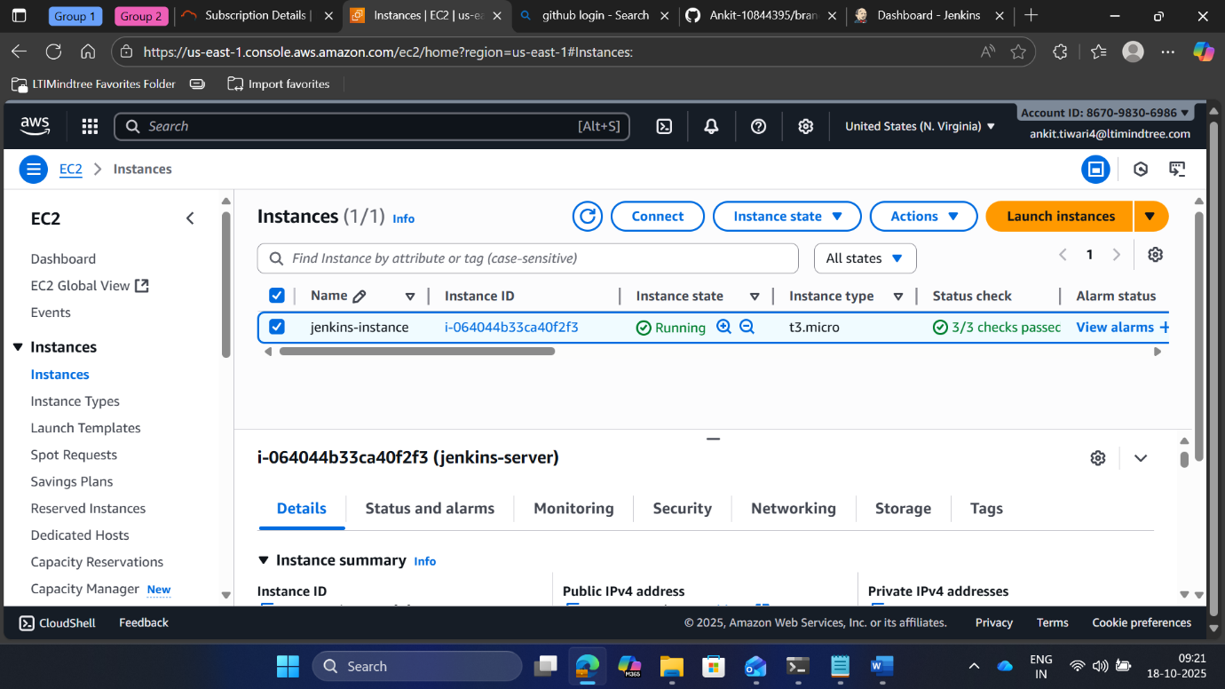

**EC2 instance specifications :**

Type/Os : Aws-linux

Subnet: us-east-1a

Size: 15G

Volume: Gp2

* + - **Jnekins-installed successfully**

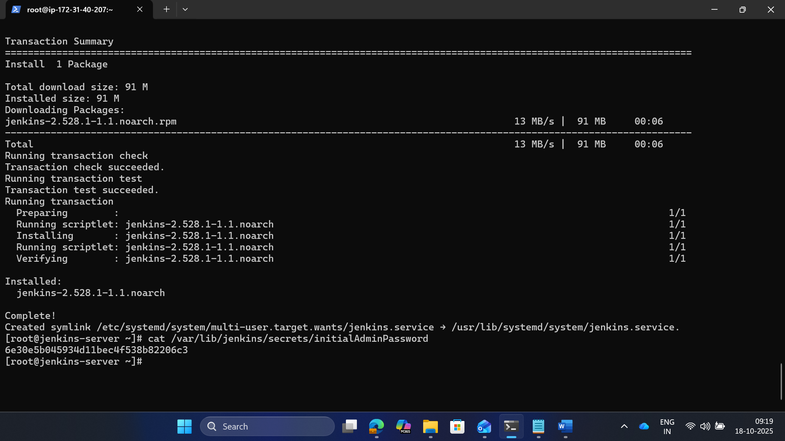

* + - **Authenticating password for Jenkins**

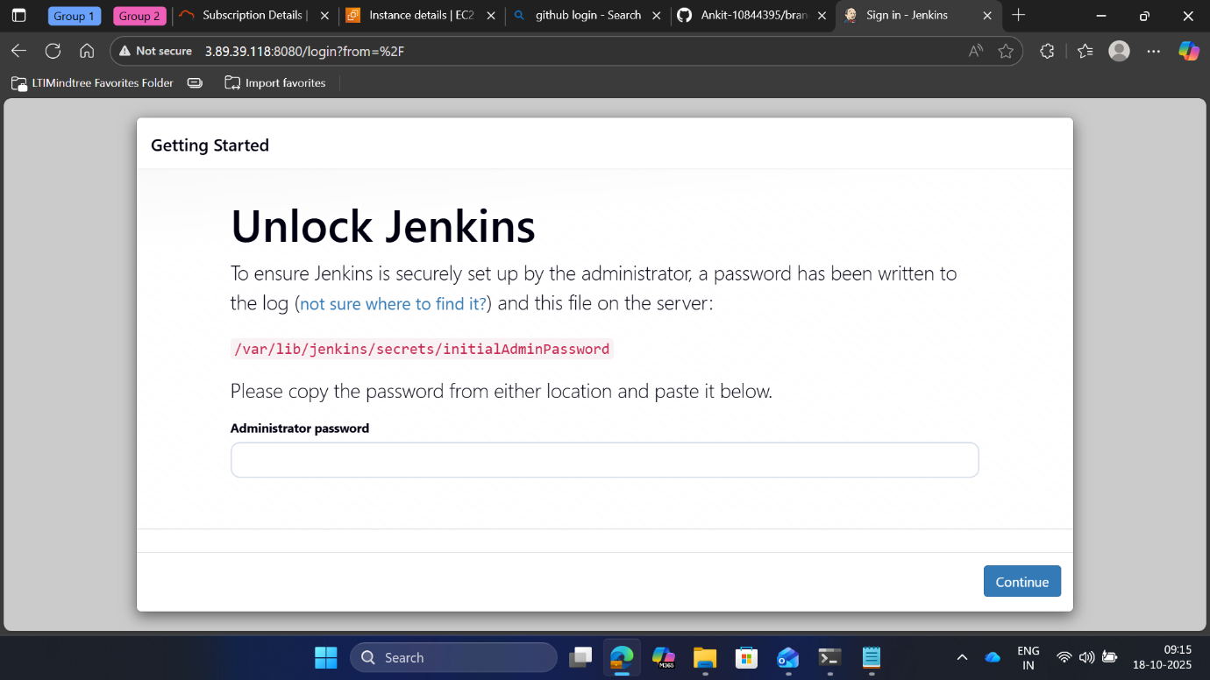

* + - **Installing suggested Pluggins**

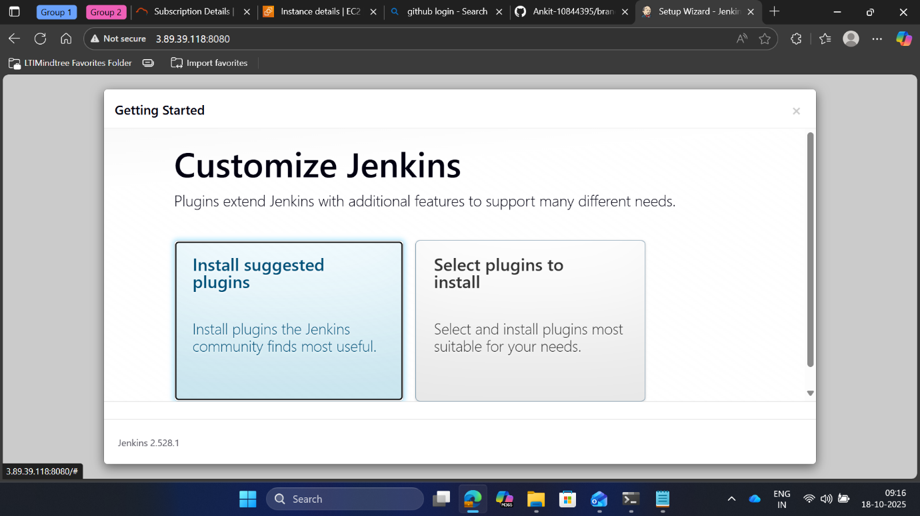

* + - **Jenkins getting started**

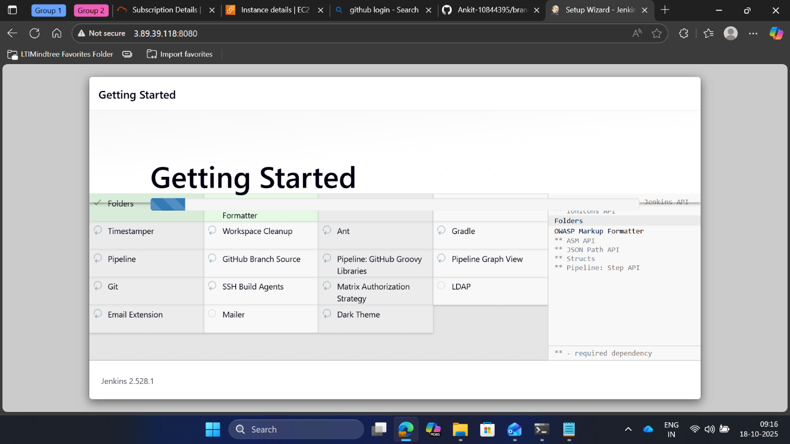

* + - **Providing user Information to access the dashboard**

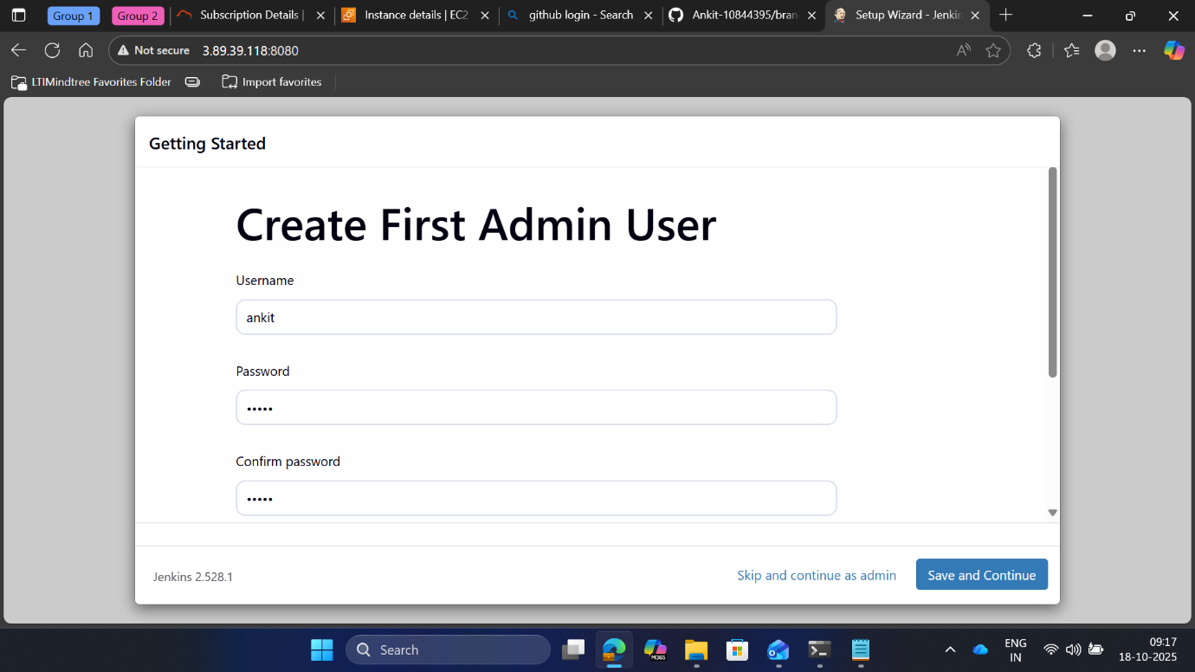

* + - **Jenkins Dashboard**

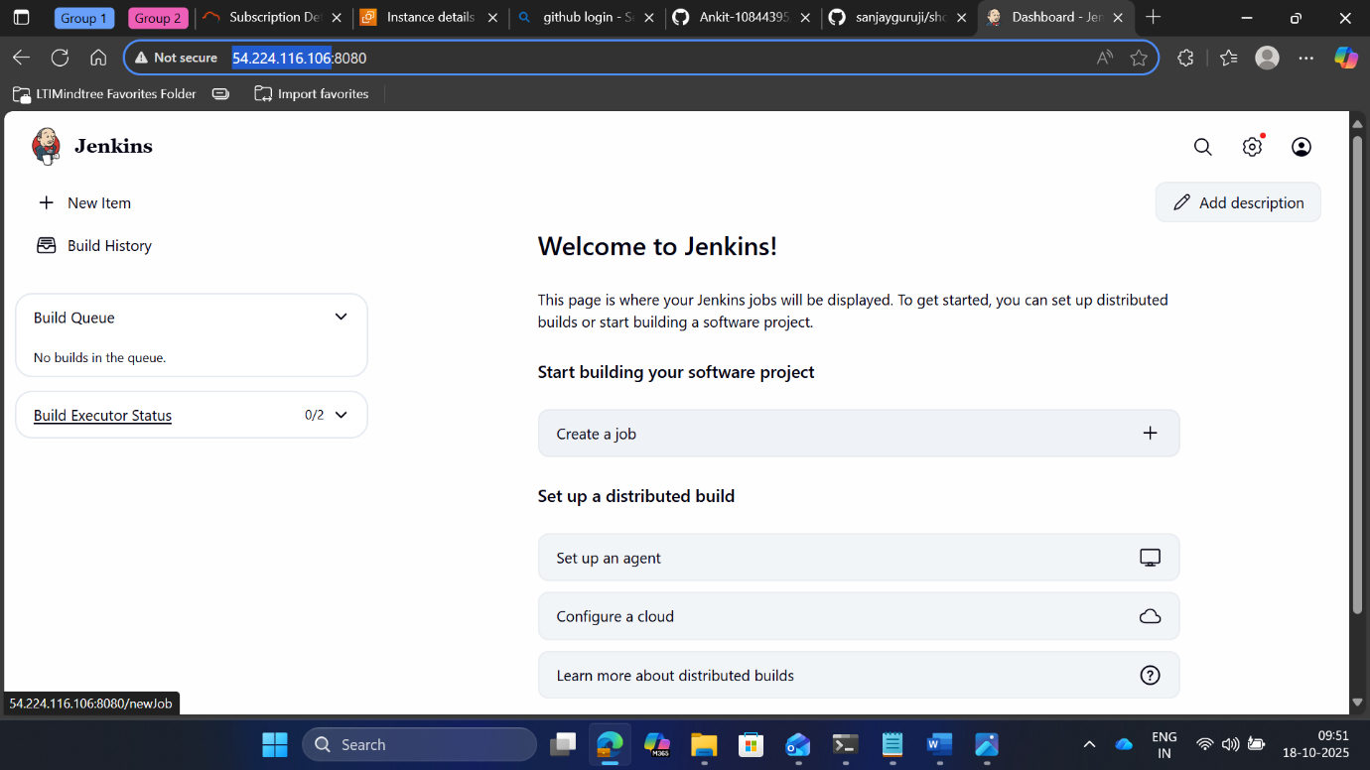

* + - **New github repository created**

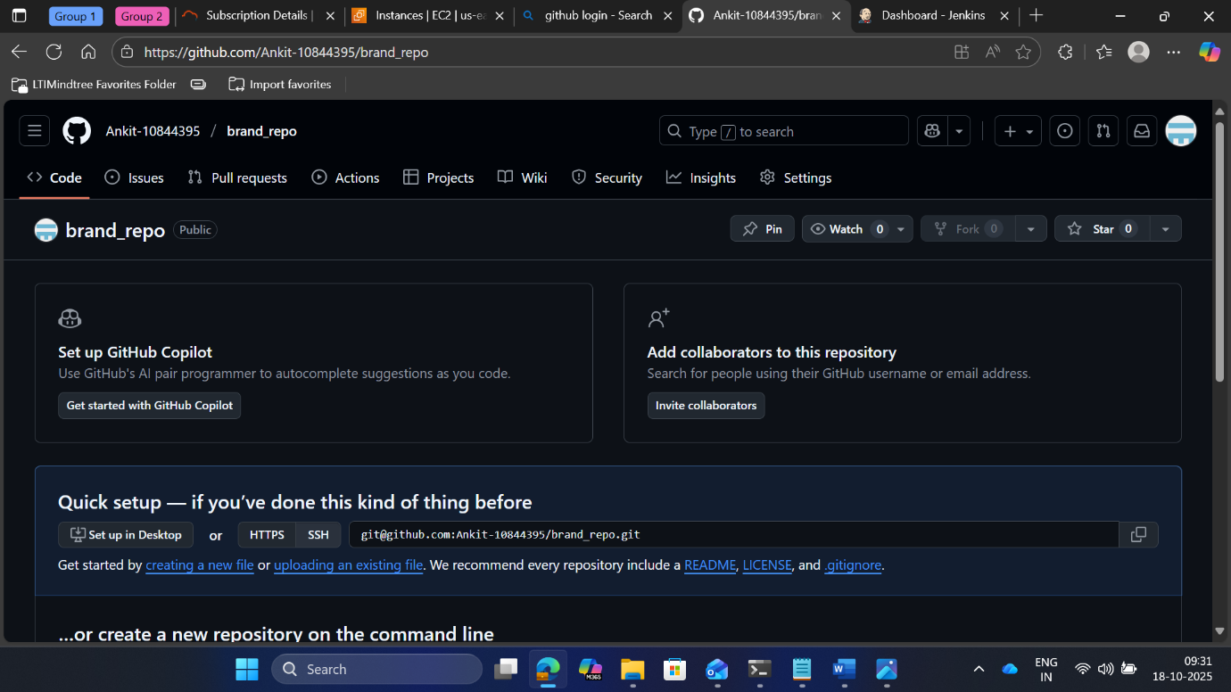

* + - **Cloning the repository consisting of java project**

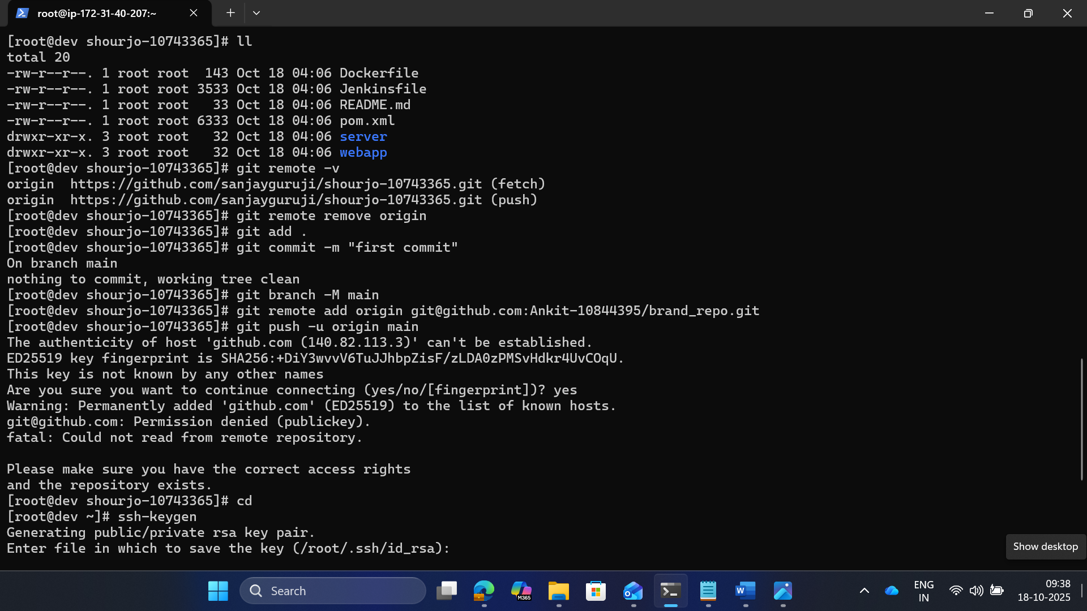

* + - **Github cloned Succesfully using ssh-key authentication**

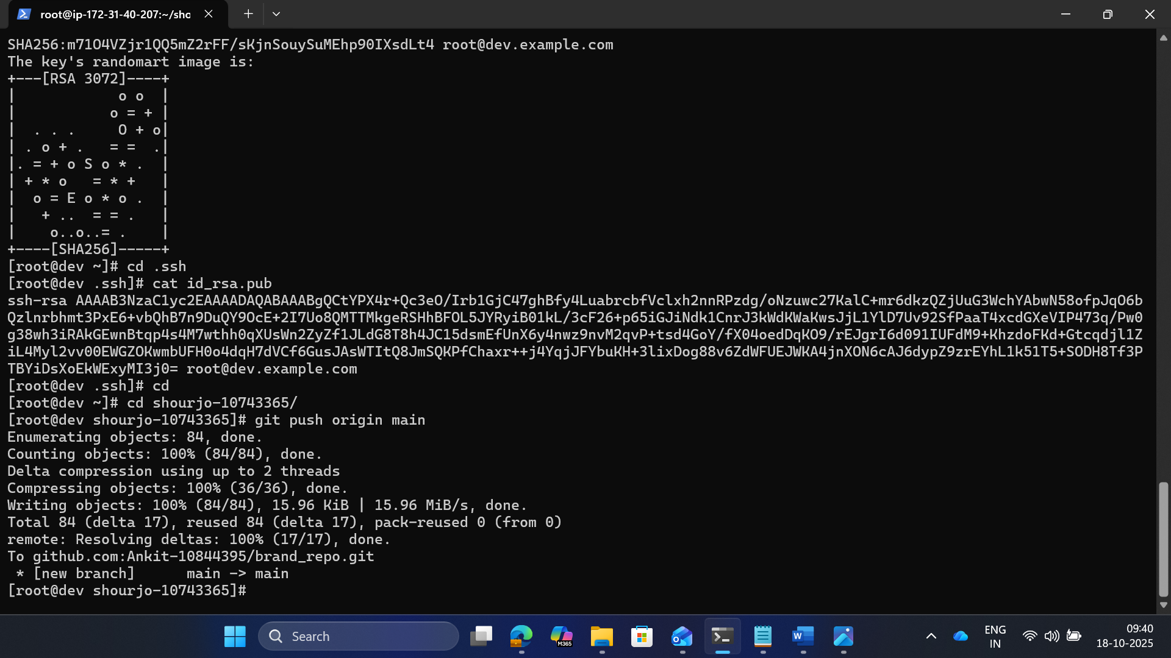

* + - **All java files obtained successfully via cloning repository**

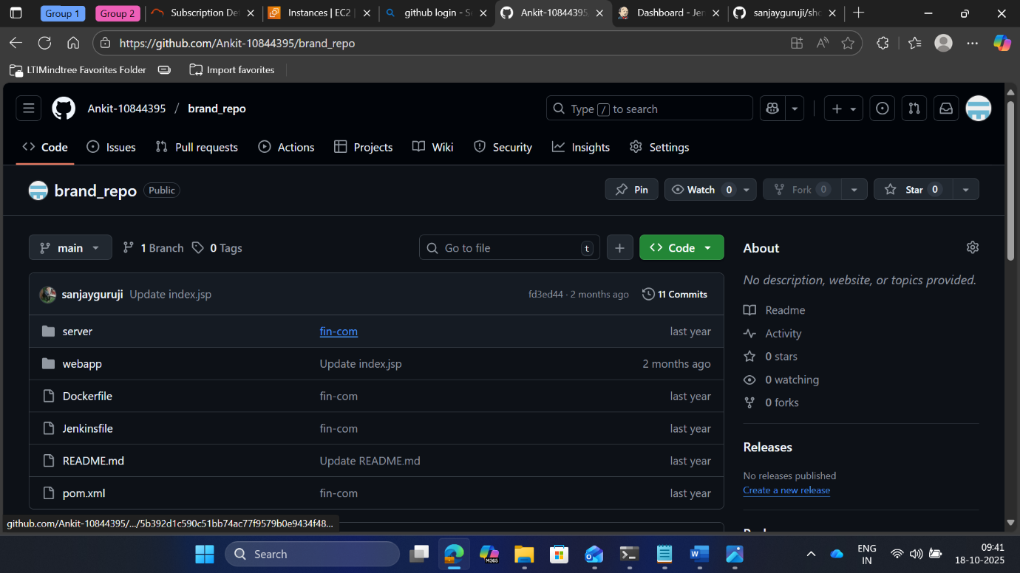

* + - **Connecting github to Jenkins via webhook using tokens**

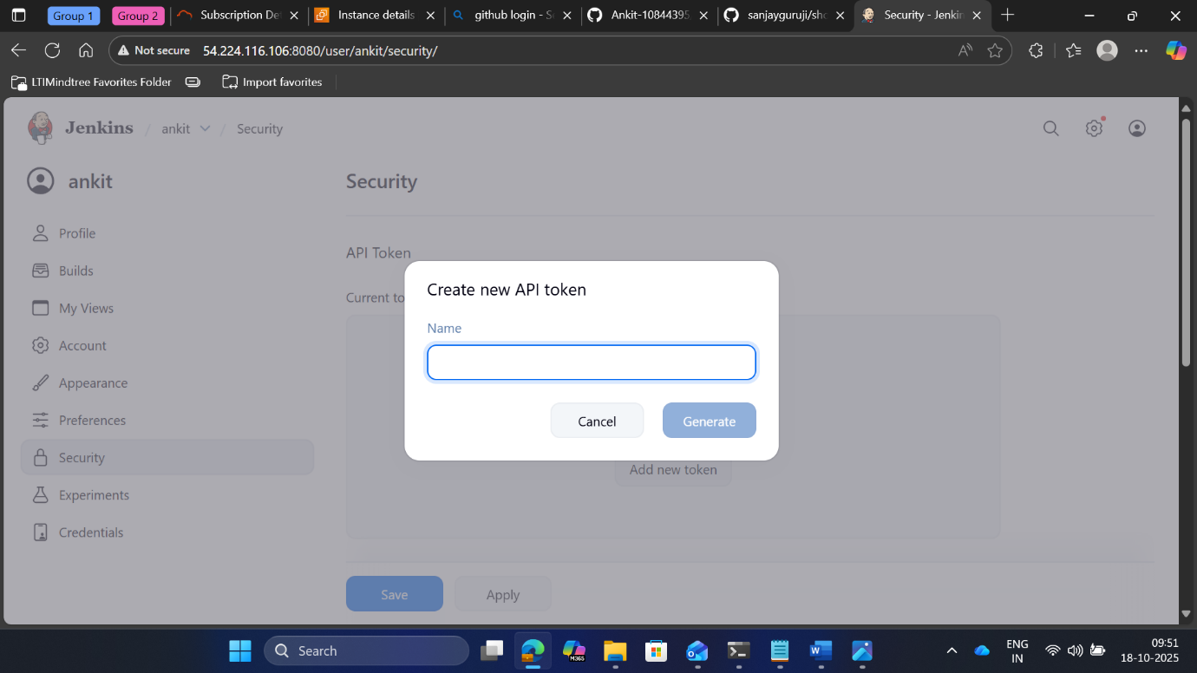

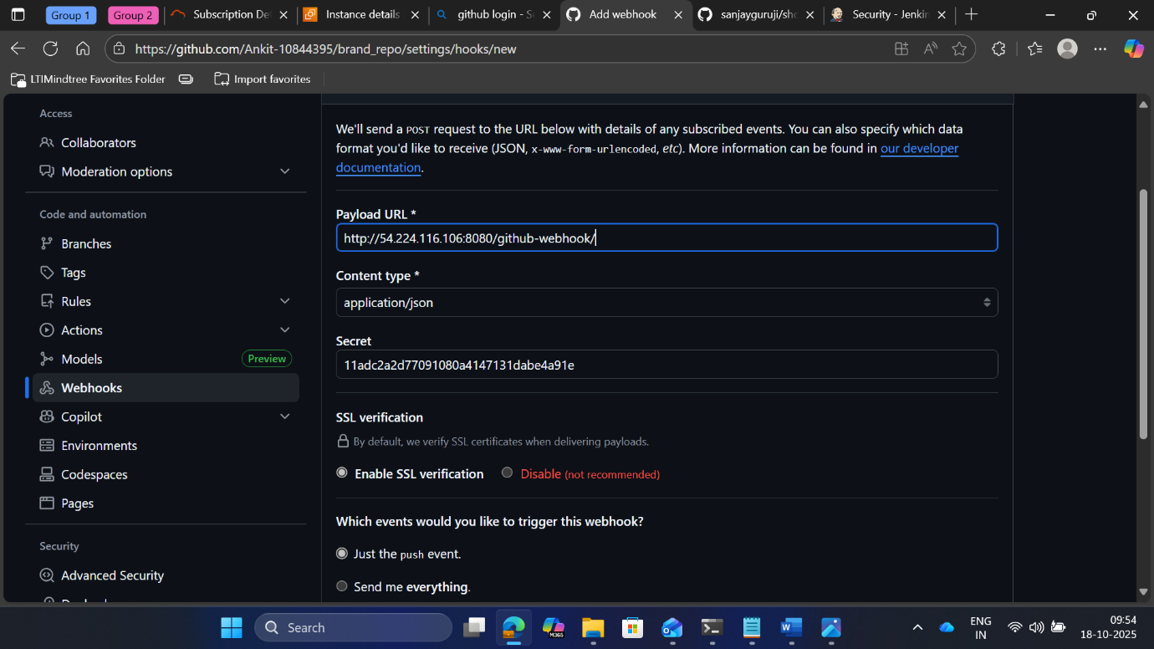

* + - **Webhook successfully connected**

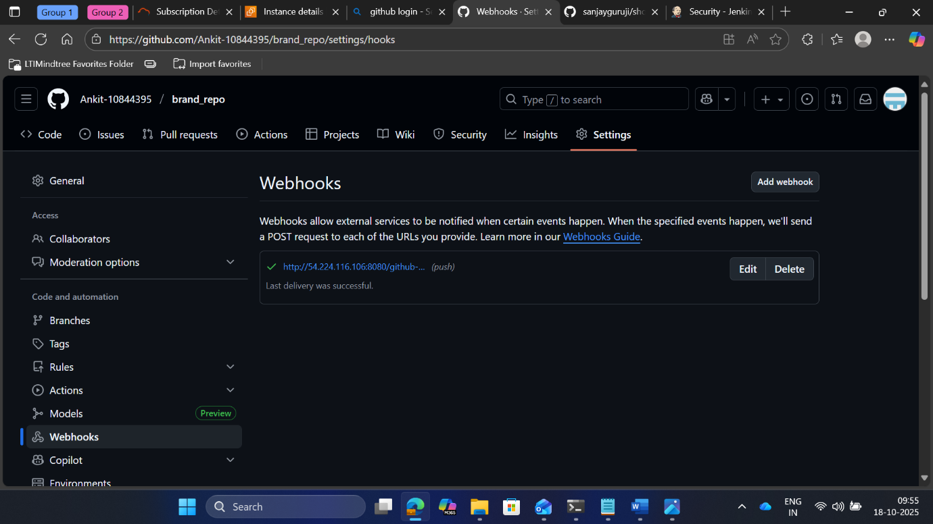

* + - **Configuring java and maven path to Jenkins tool**

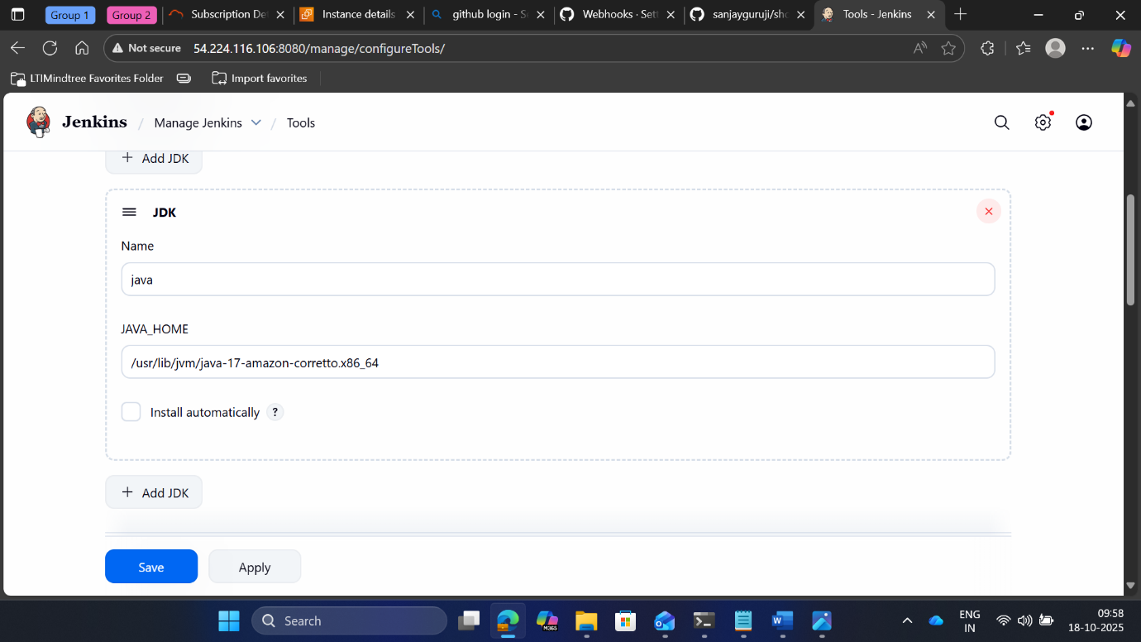

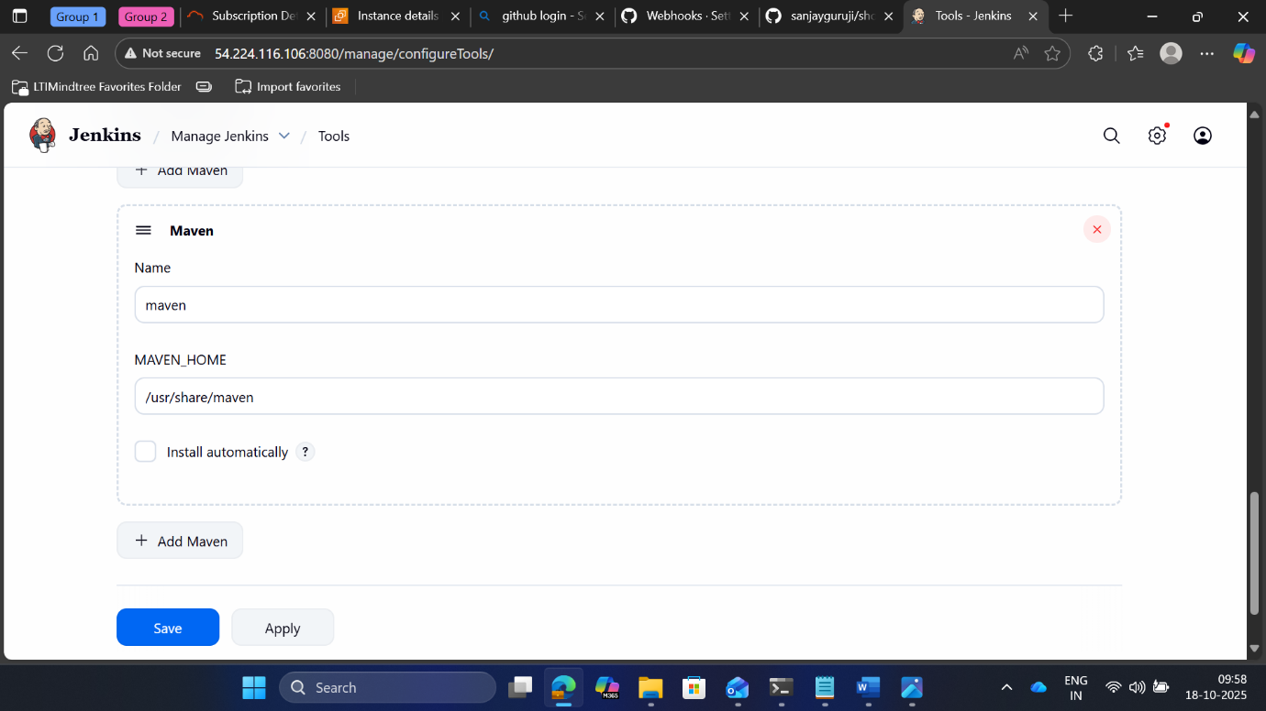

* + - **Installing essential Pluggins required for deploying & integrating**

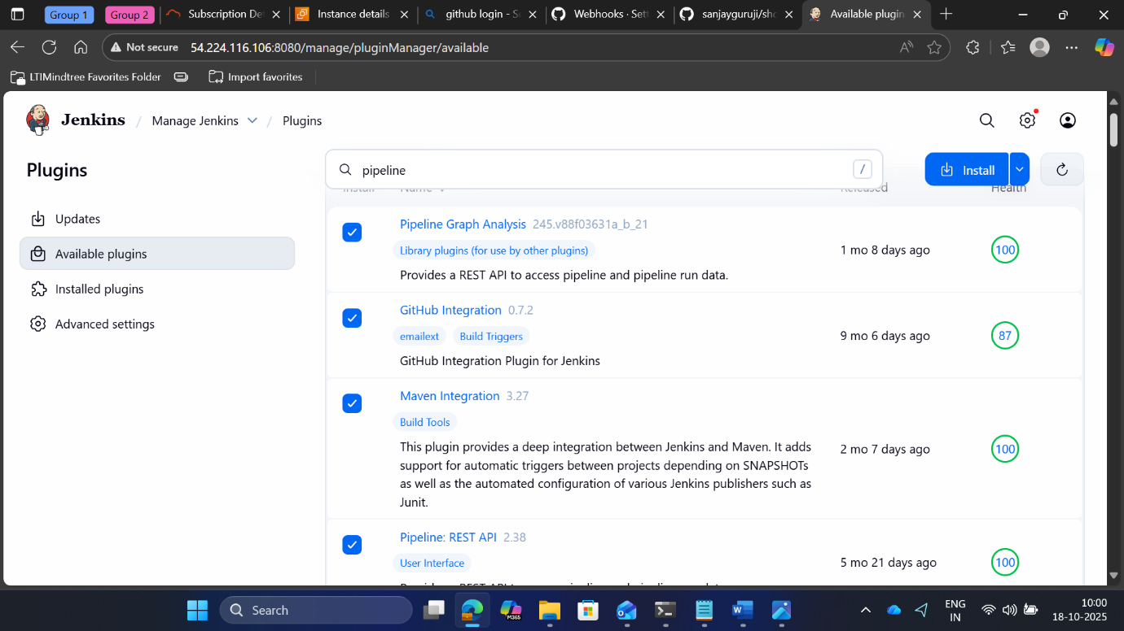

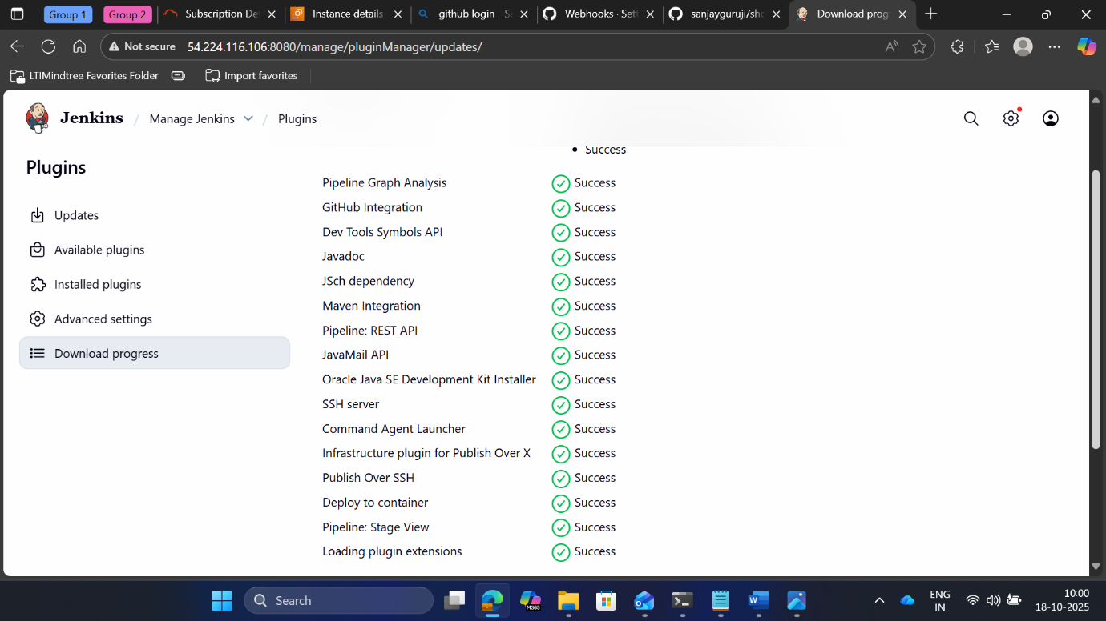

* + - **Crating another instance for tomcat**

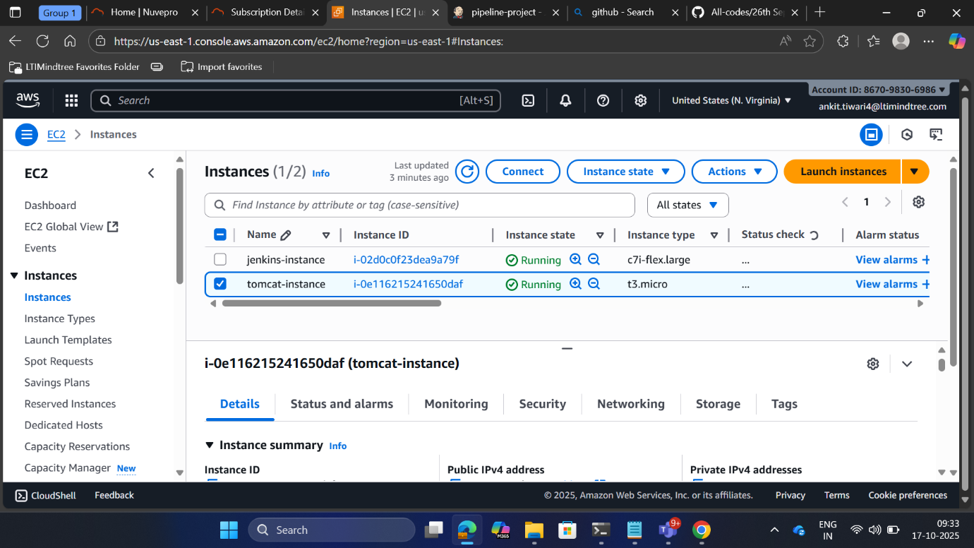

* + - **Installing all the java files on tomcat server**

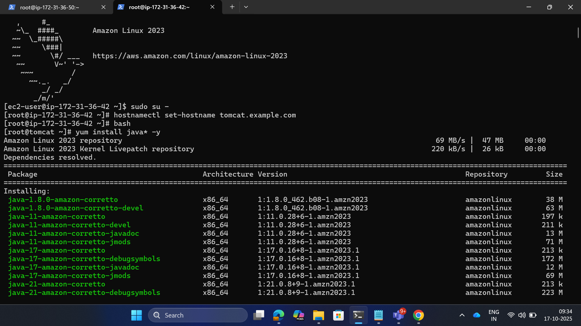

* + - **Installing tomcat 9 on the server**

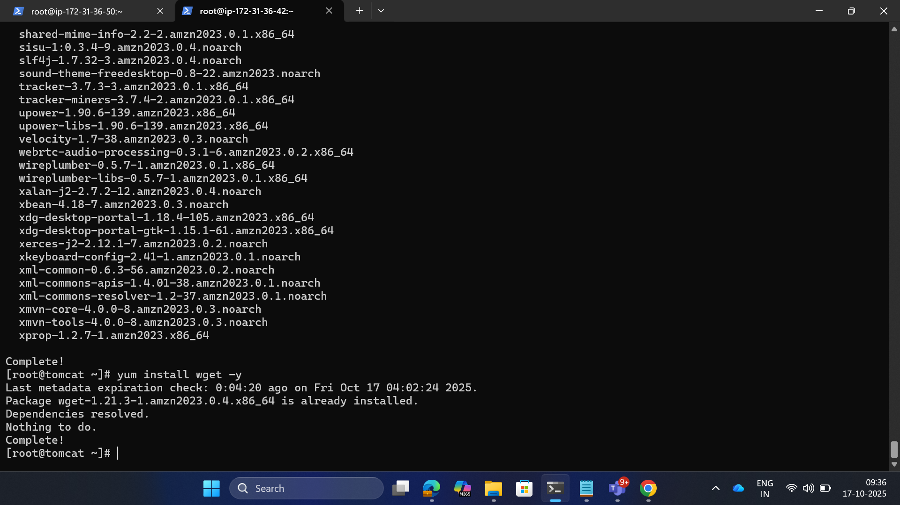

* + - **All the files are present in the tomcat apache server**

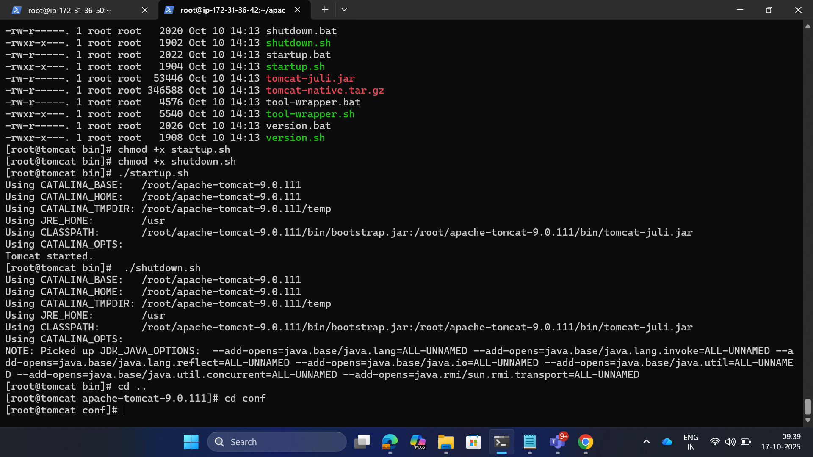

* + - **Tomcat successfully started**

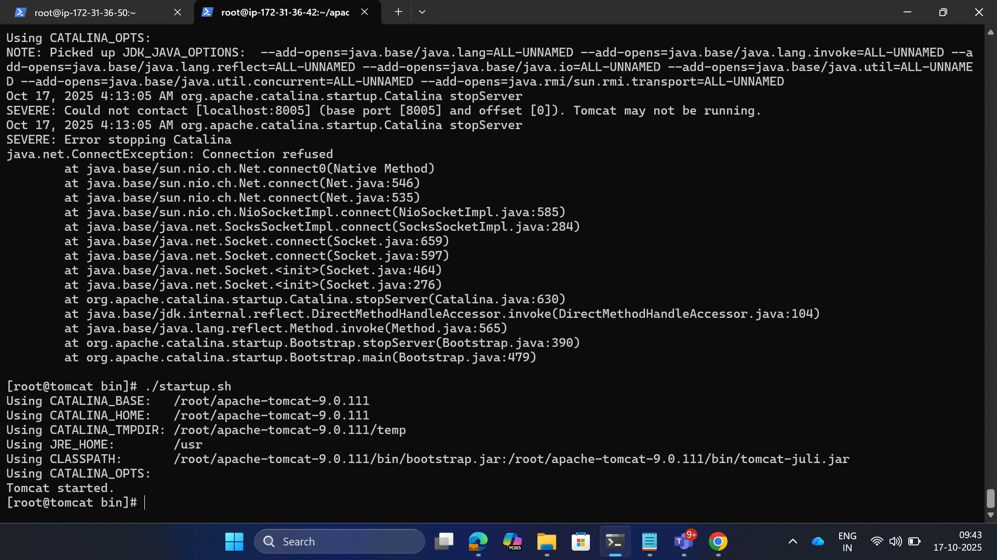

* + - **Tomcat Default page accessible**

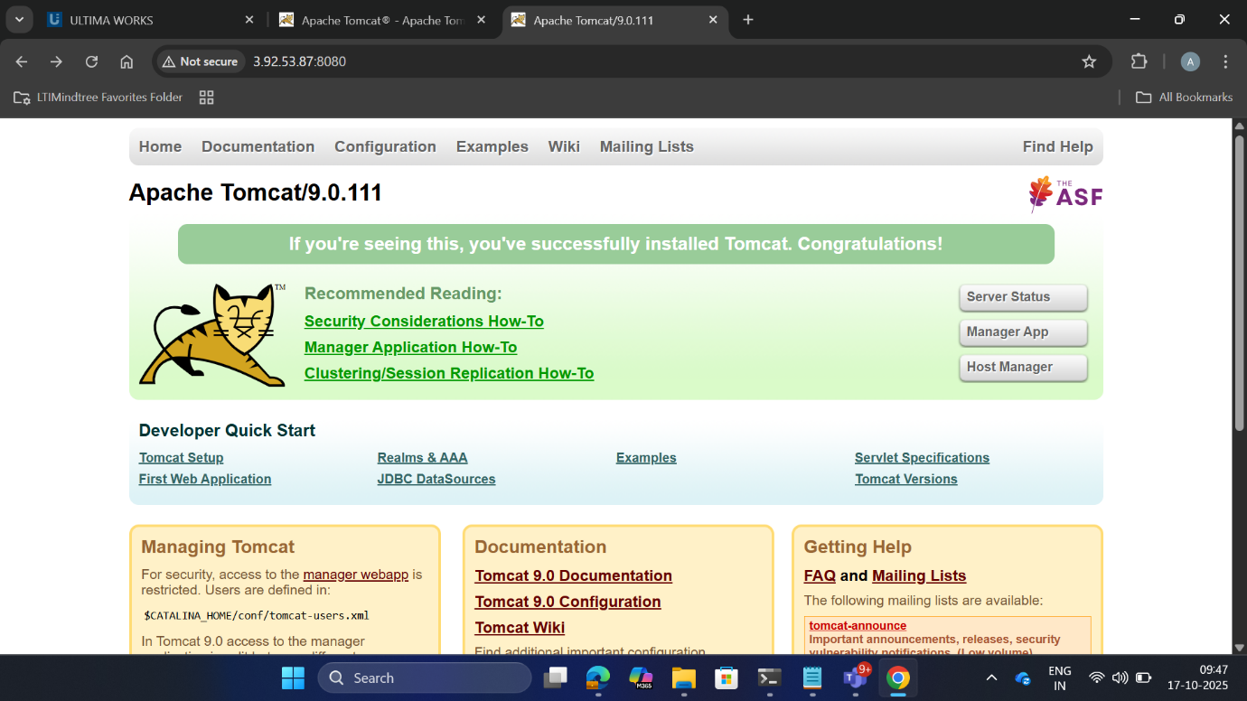

* + - **Accessing Tomcat manager to see if changes are made**

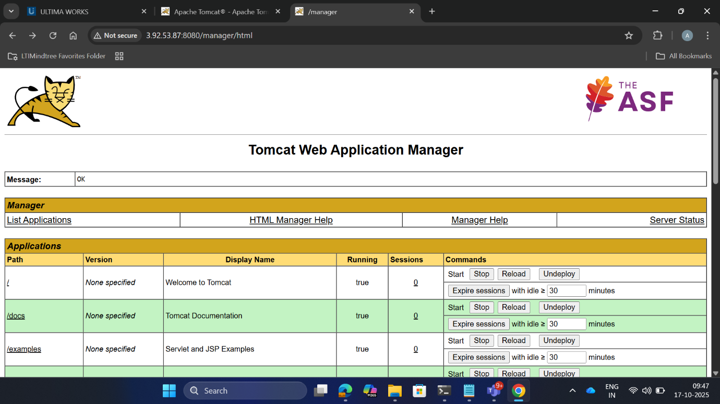

* + - **Changes are getting reflected on tomcat server**

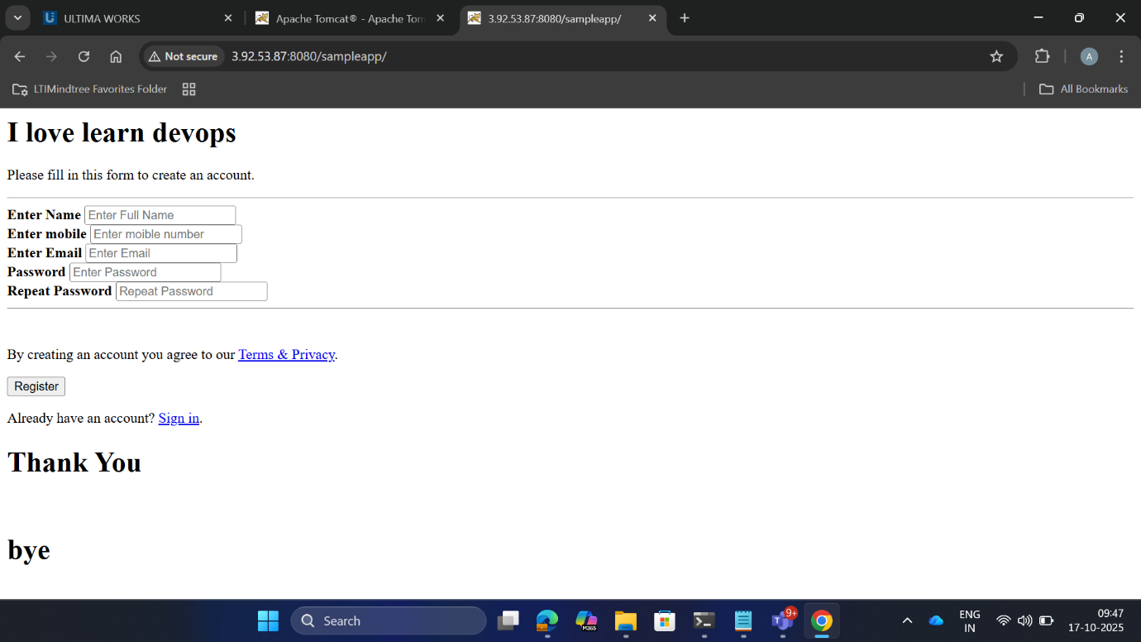

* + - **Now creating docker instance**

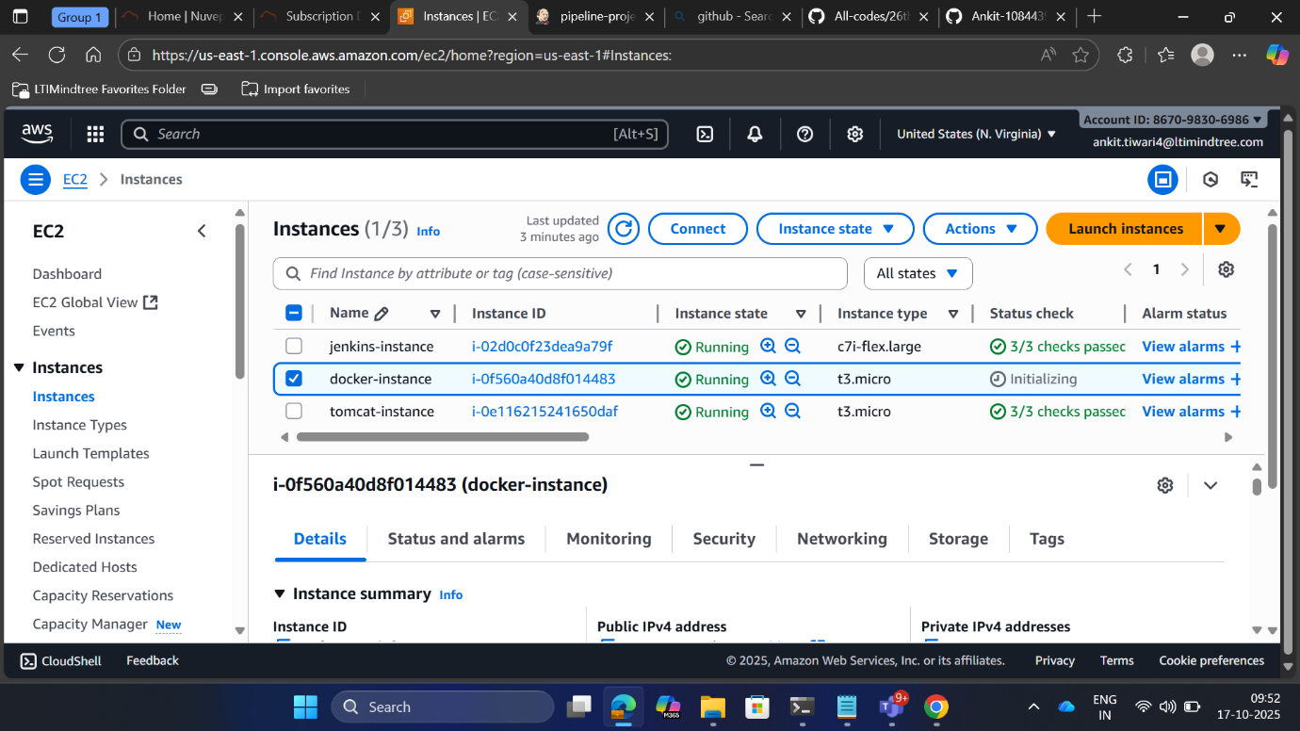

* + - **Installing docker**

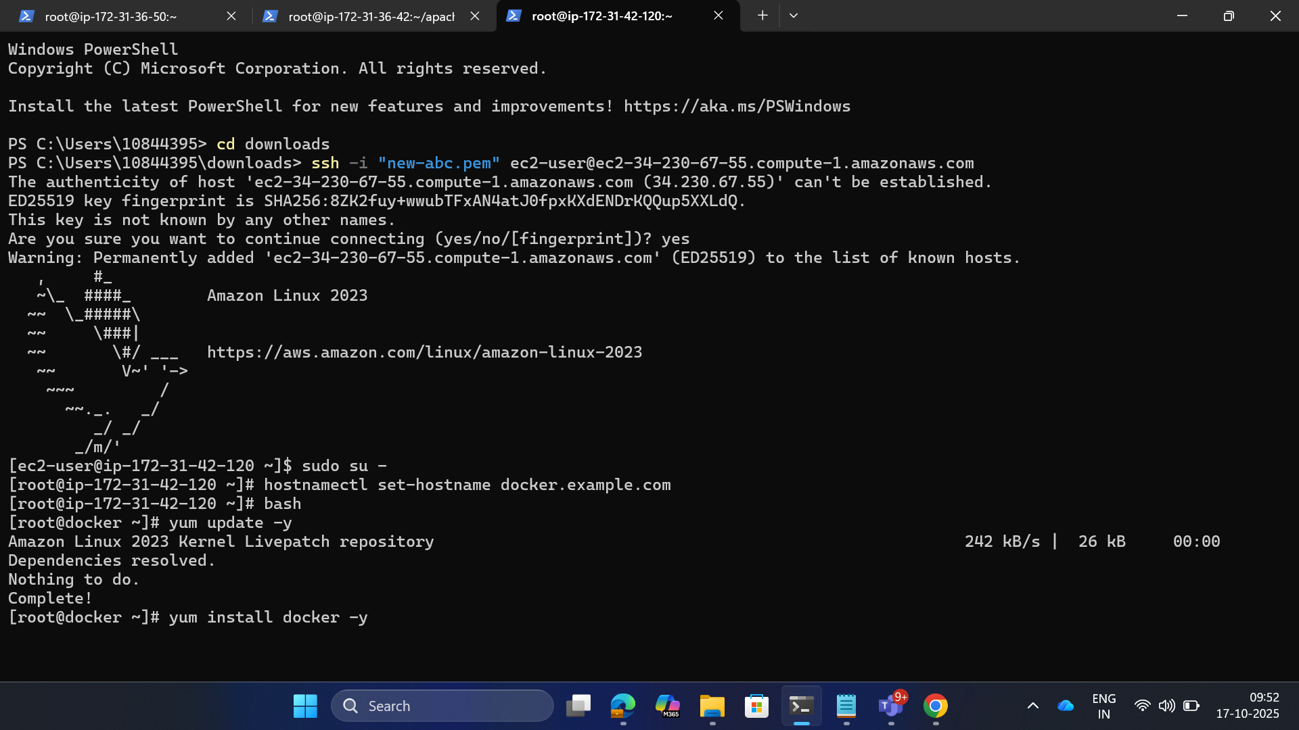

* + - **Creating new IAM user and role and providing policies**

**User : AdministorFullAcess**

**Roles: EKS-cluster , IAM full access, ec2aDMINRegistry full access**

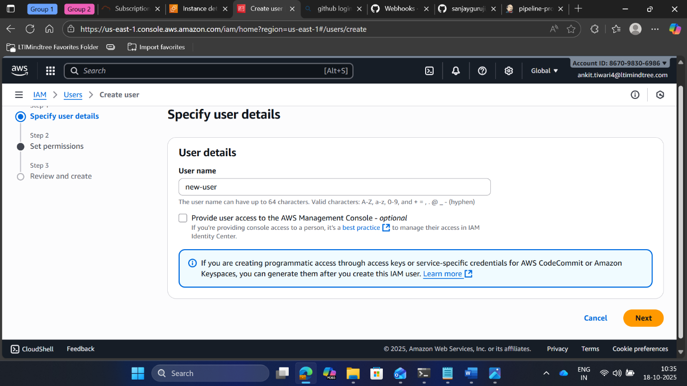

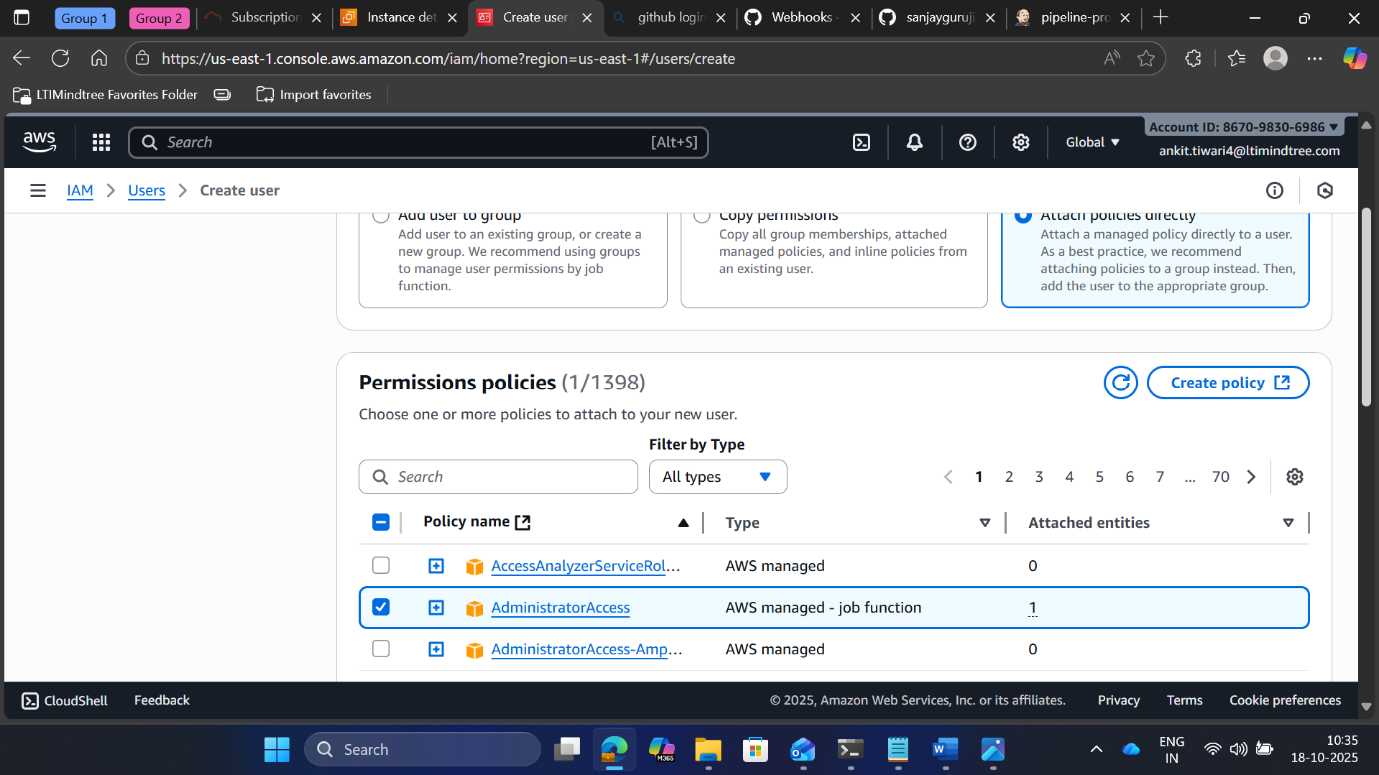

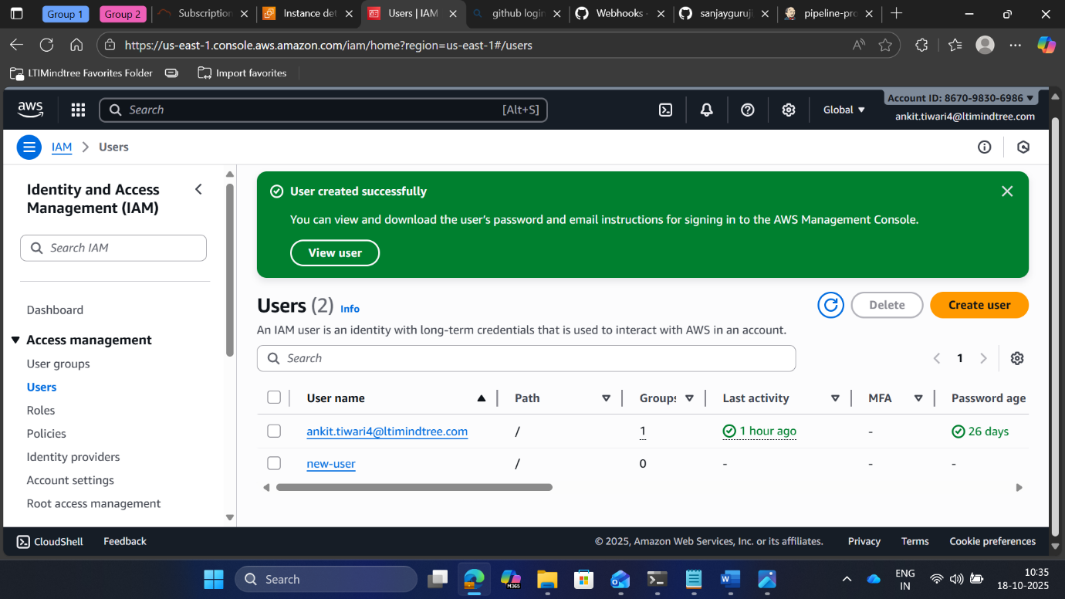

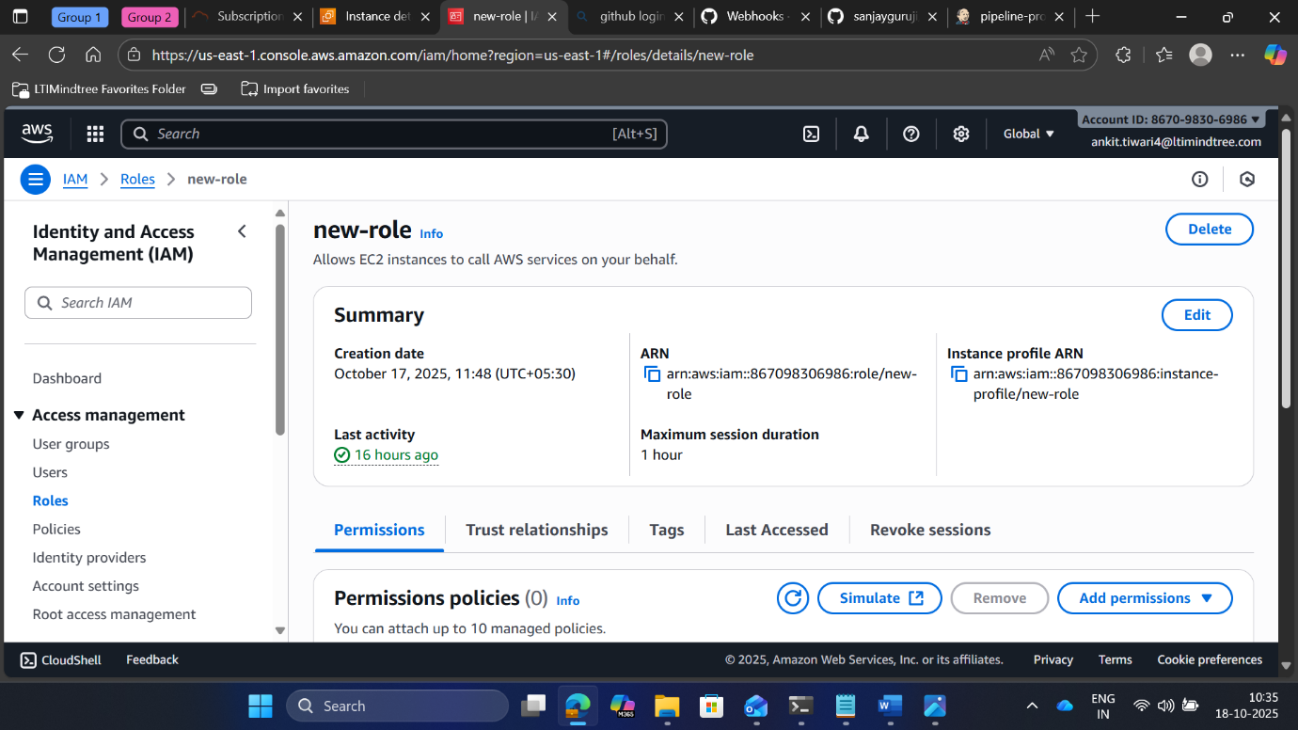

* + - **Adding SSH server for docker , Jenkins**

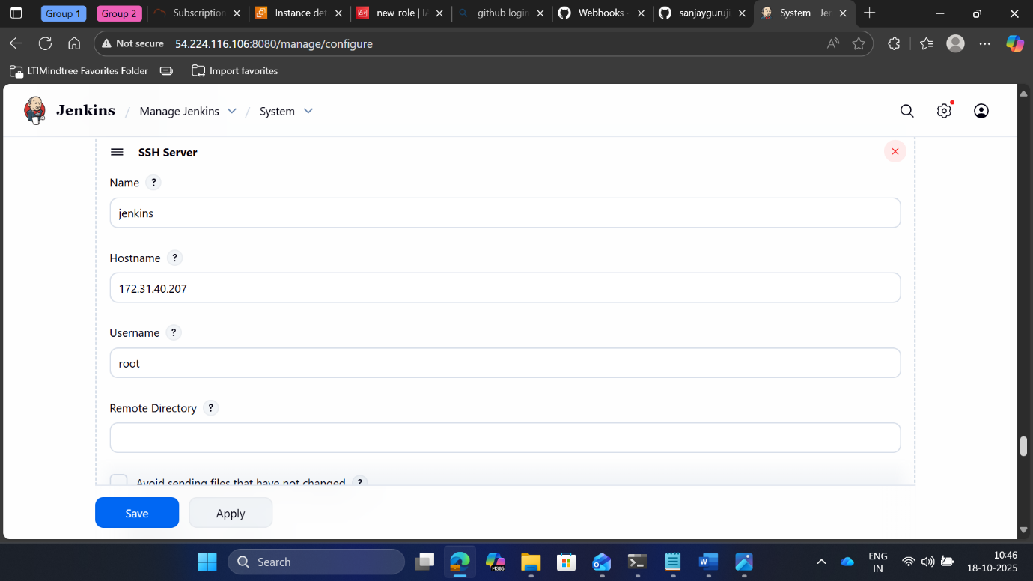

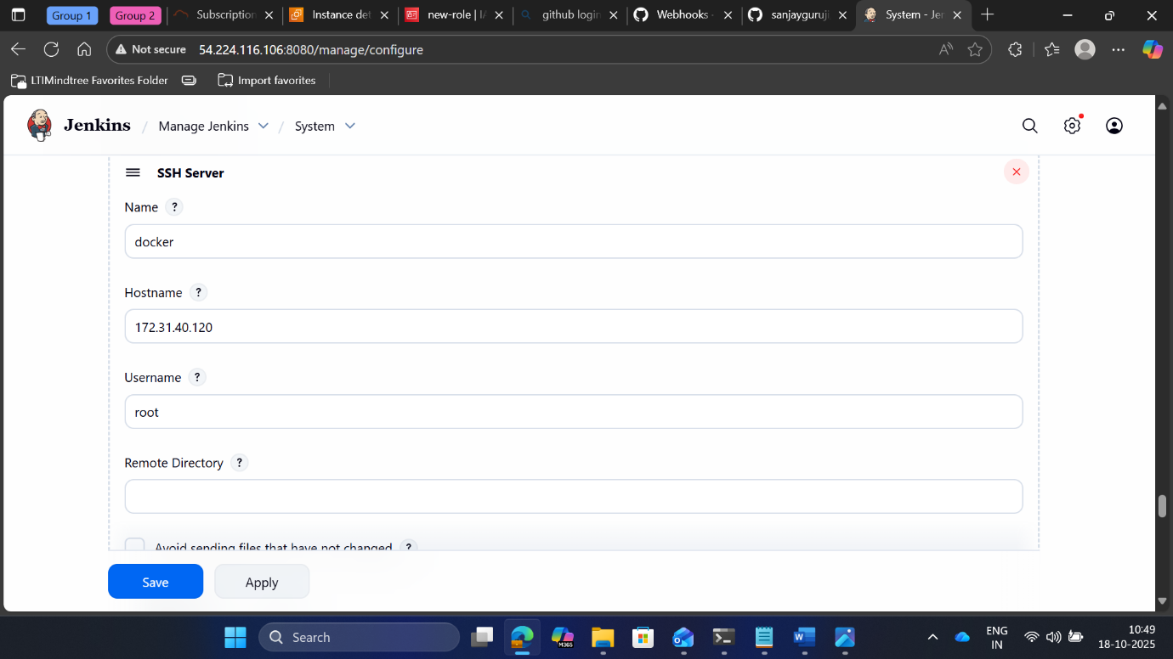

* + - **Creating elastic container registory (ECR) and accessing the images in the ecr**

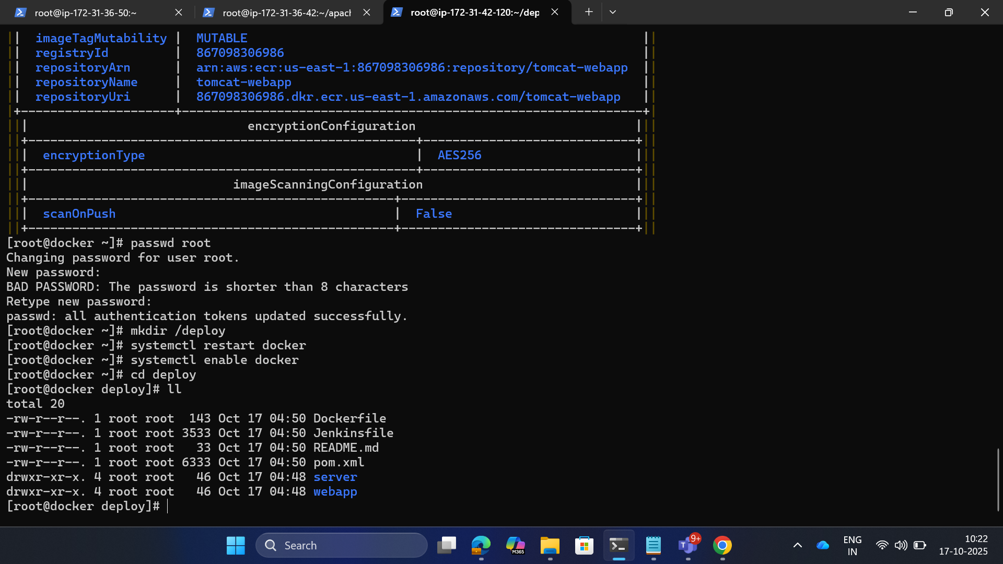

* + - **Image accessible on ECR**

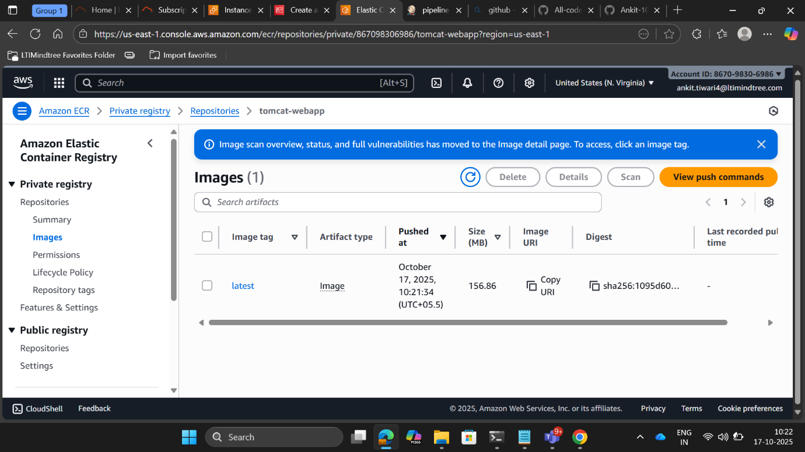

* + - **Creating eks-cluster instance for making cluster and nodes**

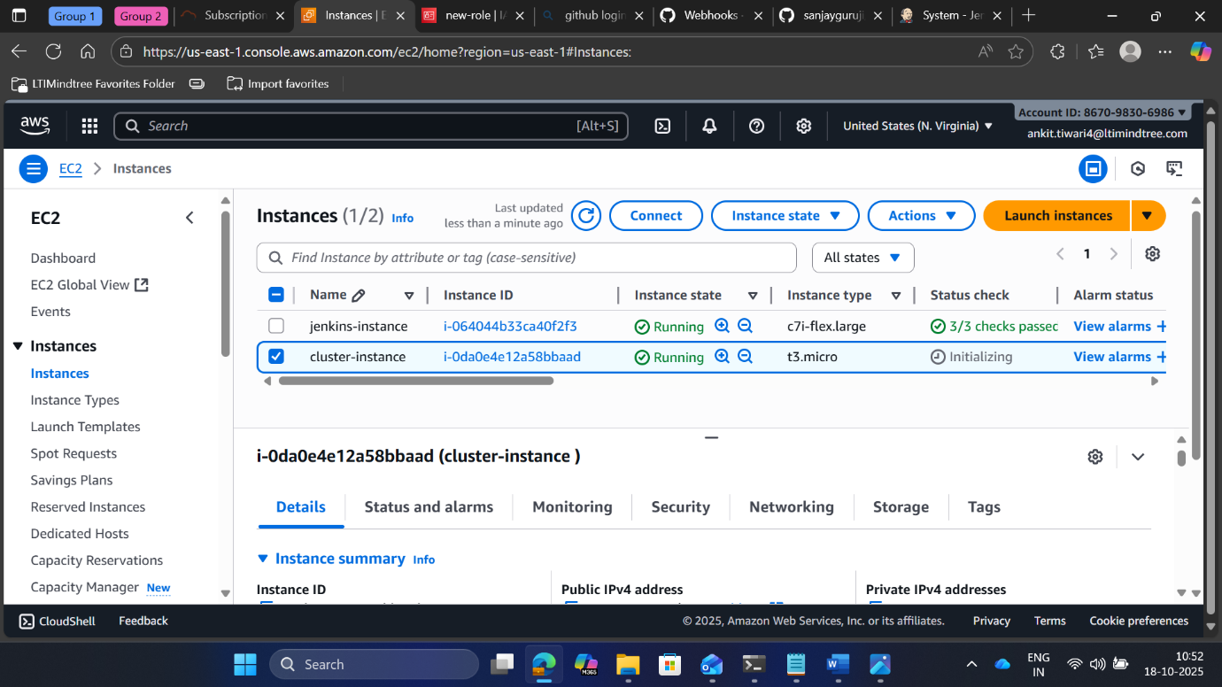

* + - **Cluster successfully created**

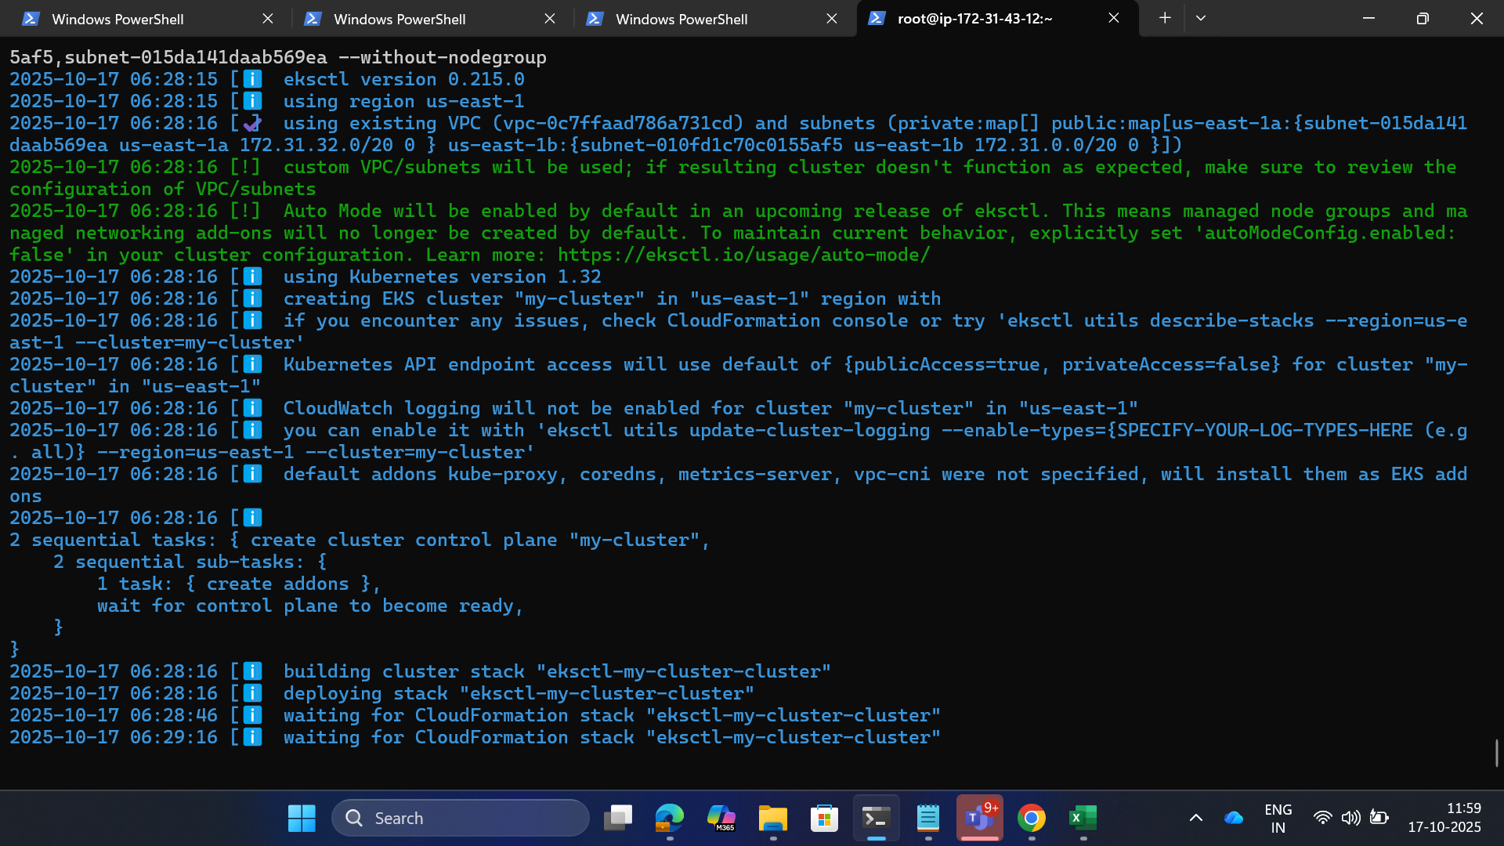

* + - **Creating node group and checking if nodes created**

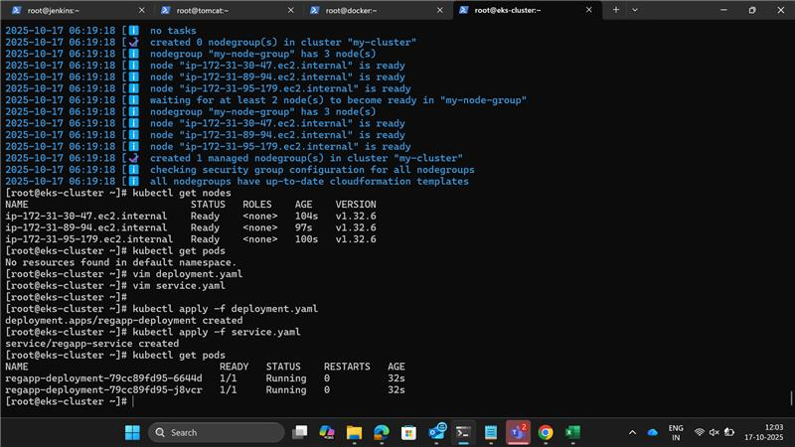

* + - **Deployment File and service file for managing and exposing the application**

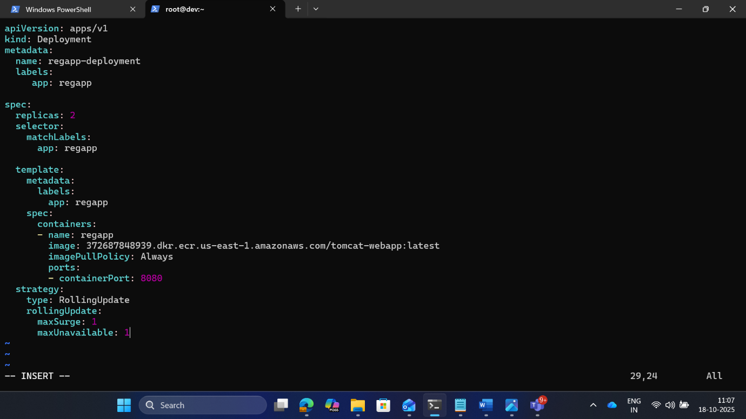

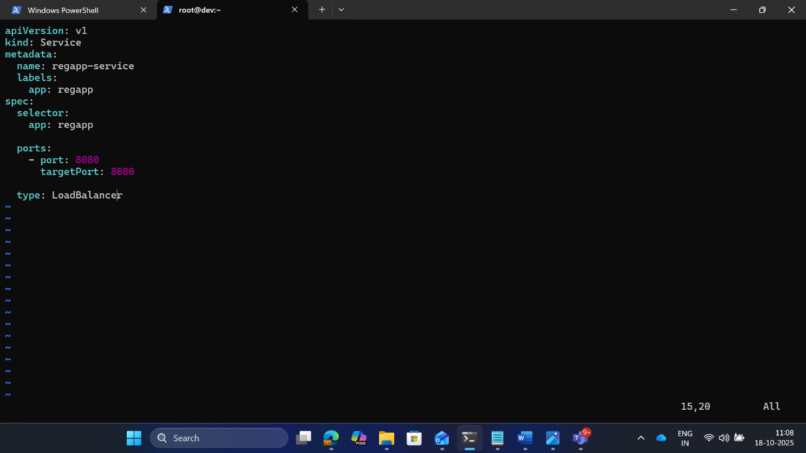

* + - Finally Building the project

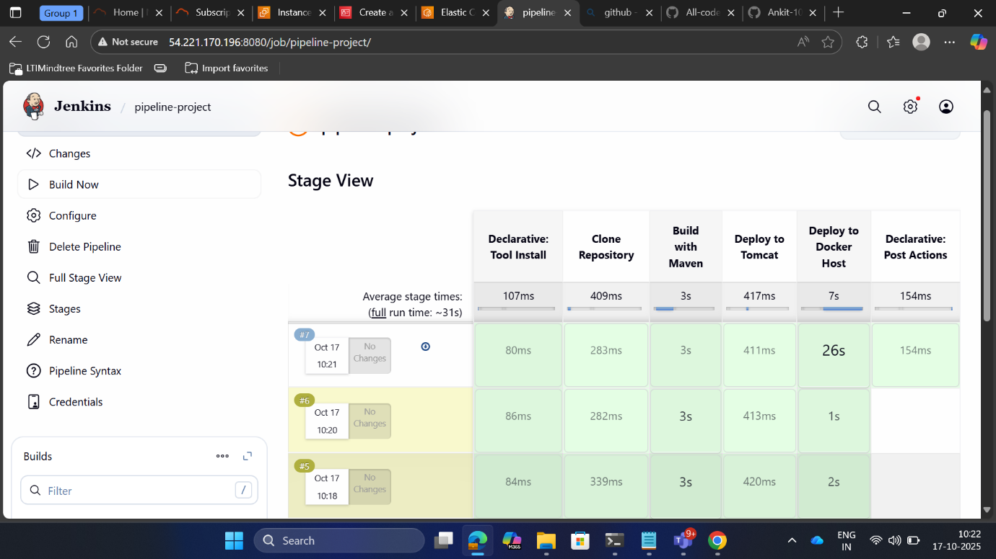

* + - The application is acccesible on external Ip

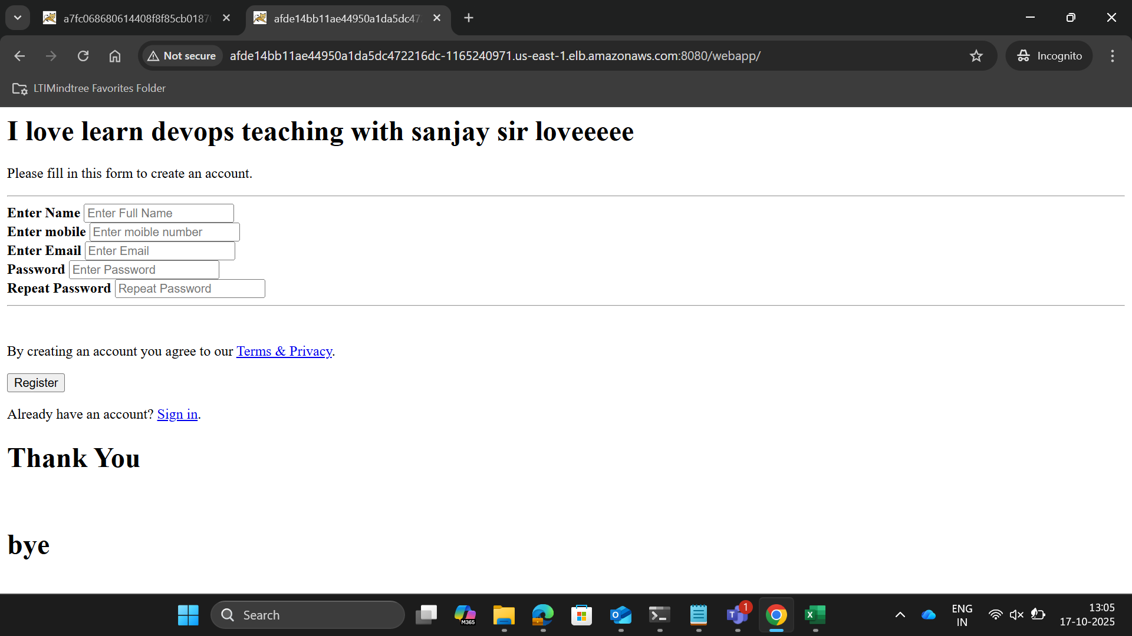

* + - Making changes to the github file and checking if reflecting

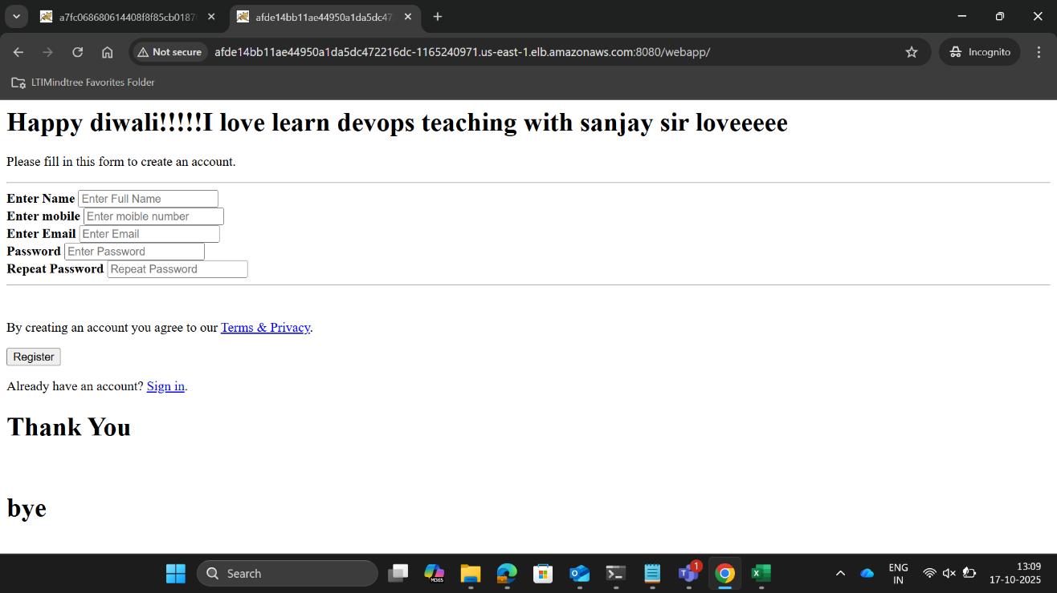

**Declarative Pipeline Script :**

**pipeline {**

**agent any**

**tools {**

**maven 'maven'**

**}**

**environment {**

**TOMCAT_USER = 'deployer'**

**TOMCAT_PASS = 'deployer'**

**TOMCAT_HOST = '3.92.53.87'**

**TOMCAT_PORT = '8080'**

**}**

**stages {**

**stage('Clone Repository') {**

**steps {**

**git branch: 'main', url: 'https://github.com/Ankit-10844395/brand-repo.git'**

**}**

**}**

**stage('Build with Maven') {**

**steps {**

**sh 'mvn clean package -Dmaven.test.failure.ignore=true'**

**}**

**}**

**stage('Deploy to Tomcat') {**

**steps {**

**sh '''**

**curl -u $TOMCAT_USER:$TOMCAT_PASS \**

**--upload-file webapp/target/webapp.war \**

**"http://$TOMCAT_HOST:$TOMCAT_PORT/manager/text/deploy?path=/sampleapp&update=true"**

**'''**

**}**

**}**

**stage('Deploy to Docker Host') {**

**steps {**

**sshPublisher(publishers: [**

**sshPublisherDesc(**

**configName: 'docker', // Must match SSH config name in Jenkins**

**transfers: [**

**sshTransfer(**

**sourceFiles: '**/*',**

**removePrefix: '',**

**remoteDirectory: 'ultima',**

**execCommand: '''**

**cd ultima**

**aws ecr get-login-password --region us-east-1 | docker login --username AWS --password-stdin 867098306986.dkr.ecr.us-east-1.amazonaws.com**

**docker build -t tomcat-webapp .**

**docker tag tomcat-webapp:latest 867098306986.dkr.ecr.us-east-1.amazonaws.com/tomcat-webapp:latest**

**docker push 867098306986.dkr.ecr.us-east-1.amazonaws.com/tomcat-webapp:latest**

**'''**

**)**

**]**

**)**

**])**

**}**

**}**

**stage('Deploy to EKS') {**

**steps {**

**withCredentials([[$class: 'AmazonWebServicesCredentialsBinding', credentialsId: 'awsconfig']]) {**

**sh '''**

**aws eks update-kubeconfig --region us-east-1 --name my-cluster**

**kubectl delete -f /new/deployment.yaml**

**kubectl apply -f /new/deployment.yaml**

**kubectl apply -f /new/service.yaml**

**kubectl rollout status deployment/regapp-deployment**

**'''**

**}**

**}**

**}**

**}**

**post {**

**success {**

**junit '**/target/surefire-reports/TEST-*.xml'**

**archiveArtifacts artifacts: '**/target/*.war', fingerprint: true**

**}**

**}**

**}**